sk_buff

The struct sk_buff is the structure representing a network packet.

Designed to easily support encapsulation/decapsulation of data through the protocol layers.

In addition to the data itself, an sk_buff maintains
-head, the start of the packet
-data, the start of the packet payload
-tail, the end of the packet payload
-end, the end of the packet
-len, the amount of data of the packet

These fields are updated when the packet goes through the protocol layers.

Function dev_alloc_skb() allows to allocate an SKB
-Can be called from an interrupt handler.
-Usually the case on reception.

On Ethernet, the size allocated is usually the length of the packet
+ 2, so that the IP header is wordaligned (the Ethernet header is
14 bytes)

skb = dev_alloc_skb(length + NET_IP_ALIGN);

On allocation, data, head and tail points to same location.

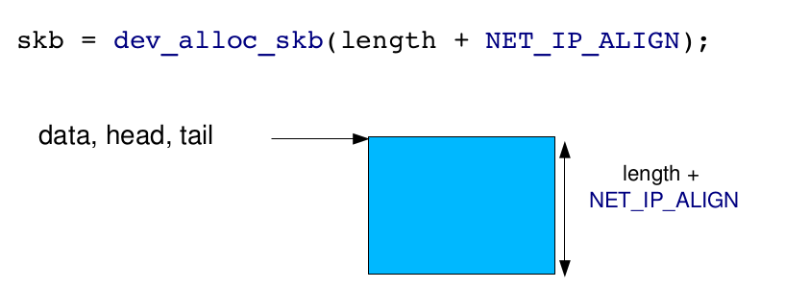

Reserving space in SKB:

Done with skb_reserve()
skb_reserve(skb, NET_IP_ALIGN);

data and tail points after NET_IP_ALIGN. Head still at the top.

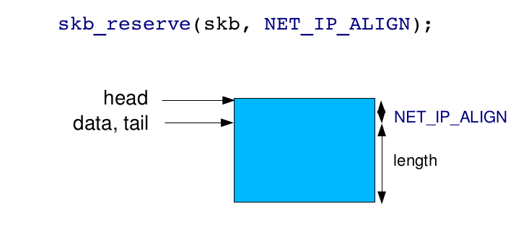

Copy the recieved data

The packet payload must be copied from the DMA buffer to the
SKB, using:

static inline void skb_copy_to_linear_data(struct sk_buff *skb, const void *from, const unsigned int len);

static inline void skb_copy_to_linear_data_offset(struct sk_buff *skb, const int offset, const void *from, const unsigned int len);

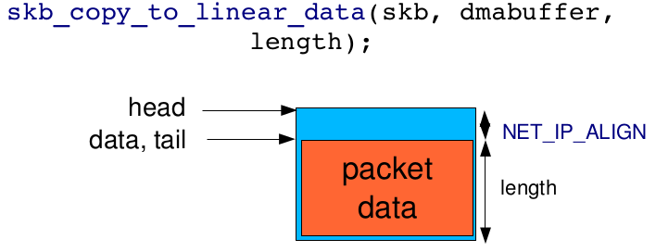

Update pointers in SKB

skb_put() is used to update the SKB pointers after copying the
payload.

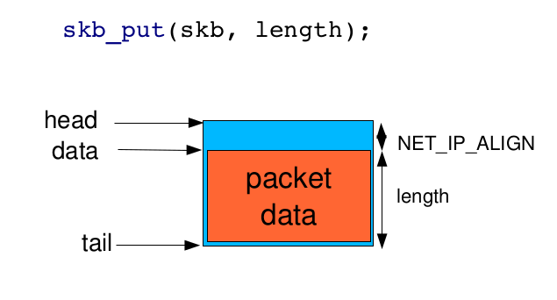

struct net_device

This structure represents a single network interface.

Allocation takes place with alloc_etherdev().

The size of private data must be passed as argument. The pointer
to these private data can be read in net_device>priv.

alloc_etherdev() is a specialization of alloc_netdev() for Ethernet interfaces.

Registration with register_netdev()

Unregistration with unregister_netdev()

Liberation with free_netdev()

struct net_device_ops

- declares the methods of a network interface.

The most important ones:

ndo_open(), called when the network interface is up'ed

ndo_close(), called when the network interface is down'ed

ndo_start_xmit(), to start the transmission of a packet

And others:

ndo_get_stats(), to get statistics

ndo_do_ioctl(), to implement device specific operations

ndo_set_rx_mode(), to select promiscuous, multicast, etc.

ndo_set_mac_address(), to set the MAC address

ndo_set_multicast_list(), to set multicast filters

static const struct net_device_ops rtl8101_netdev_ops = {
.ndo_open = rtl8101_open,
.ndo_stop = rtl8101_close,
.ndo_start_xmit = rtl8101_start_xmit,
.ndo_tx_timeout = rtl8101_tx_timeout,
.ndo_get_stats = rtl8101_get_stats,
};
Set the netdev_ops field in the struct net_device structure to point to the struct net_device_ops structure.
dev->netdev_ops = &rtl8101_netdev_ops;

Utility functions

netif_start_queue()
Tells the kernel that the driver is ready to send packets

netif_stop_queue()
Tells the kernel to stop sending packets. Useful at driver cleanup of course, but also when all transmission buffers are full.

netif_queue_stopped()
Tells whether the queue is currently stopped or not

netif_wake_queue()
Wakeup a queue after a netif_stop_queue(). The kernel will resume sending packets.

Packet Transmission

The driver implements the ndo_start_xmit() operation.

The kernel calls this operation with a SKB as argument
static int rtl8101_start_xmit(struct sk_buff *skb, struct net_device *dev)

The driver sets up DMA buffers and other hardware-dependent mechanisms and starts the transmission.

Depending on the number of free DMA buffers available, the driver
can also stop the queue with netif_stop_queue()

When the packet has been sent, an interrupt is raised. The driver
is responsible for
-Acknowledging the interrupt.
-Freeing the used DMA buffers.
-Freeing the SKB with dev_kfree_skb_irq()
-If the queue was stopped, start it again.

Returns NETDEV_TX_OK or NETDEV_TX_BUSY.

Packet Reception

Original Mode

Reception is notified by an interrupt. The interrupt handler should:
-Allocate an SKB with dev_alloc_skb()
-Reserve the 2 bytes offset with skb_reserve()
-Copy the packet data from the DMA buffers to the SKB
skb_copy_to_linear_data() or
skb_copy_to_linear_data_offset()
-Update the SKB pointers with skb_put()
-Update the skb->protocol field with eth_type_trans(skb, netdevice)
-Give the SKB to the kernel network stack with netif_rx(skb)

NAPI Mode
The original mode is nice and simple, but when the network traffic is
high, the interrupt rate is high. The NAPI mode allows to switch to
polled mode when the interrupt rate is too high.

1) In the network interface private structure, add a struct napi_struct.

typedef struct _DrvPvt{
...
...
struct napi_struct napi;
..
}DrvPvt;

2) At driver initialization, register the NAPI poll operation:
netif_napi_add(dev, &pvt->napi, rtl8101_poll, R8101_NAPI_WEIGHT);

- dev is the network interface
-pvt->napi is the struct napi_struct
-rtl8101_poll is the NAPI poll operation.
- R8101_NAPI_WEIGHT is the «weight» that represents the importance of the network
interface. It limits the number of packets each interface can feed to the
networking core in each polling cycle. If this quota is not met, the driver
will return back to interrupt mode. Don't send this quota to a value
greater than the number of packets the interface can store.

3) In the interrupt handler, when a packet has been received ,call napi_schedule().

DrvPvt *pvt = netdev_priv(dev);
..
napi_schedule(&pvt->napi);

The kernel will call our poll() operation regularly. The poll() operation has the following prototype
static int rtl8101_poll(struct napi_struct *napi_ptr, int budget);

It must receive at most budget packets and push them to the network stack using:
netif_receive_skb(skb)
if LINUX_VERSION_CODE < KERNEL_VERSION(2,6,29)
napi_gro_receive(&pvt->napi, skb);
oterhwise.

If less than budget packets have been received, switch back to interrupt mode using
if (work_done < budget)
{
napi_complete(napi_ptr);
..

and reenable interrupts.
rtl8101_enable_interrupts(reg_base, IntrEnMask);

Must return the number of packets received
return work_done;

Communication with PHY
-Usually, on embedded platforms, the SoC contains the Ethernet
controller, that takes care of layer 2 (MAC) communication.

-An external PHY is responsible for layer 1 communication.

-The MAC and the PHY are connected using a MII or RMII interface:
MII = Media Independent Interface
RMII = Reduced Media Independent Interface

- This interface contains two wires used for the MDIO bus
(Management Data Input/Output)

The Ethernet driver needs to communicate with the PHY to get
information about the link (up, down, speed, full or half duplex)
and configure the MAC accordingly

PHY in kernel

The kernel provides a framework that:
- Exposes an API to communicate with the PHY
- Allows to implement PHY drivers.
- Implements a basic generic PHY driver that works with all PHY.

-Implemented in drivers/net/phy/
-Documented in Documentation/networking/phy.txt

-The driver must create a MDIO bus structure that tells the PHY infrastructure how to communicate with the PHY.

- Allocate a MDIO bus structure
struct mii_bus *mii_bus = mdiobus_alloc();

- Fill the MDIO bus structure:

struct mii_bus *new_bus;
int ret;

new_bus = devm_mdiobus_alloc(&pdev->dev);
if (!new_bus)
return -ENOMEM;

new_bus->name = "r8169";
new_bus->priv = tp;
new_bus->parent = &pdev->dev;
new_bus->irq[0] = PHY_IGNORE_INTERRUPT;
snprintf(new_bus->id, MII_BUS_ID_SIZE, "r8169-%x", pci_dev_id(pdev));

new_bus->read = r8169_mdio_read_reg;
new_bus->write = r8169_mdio_write_reg;

ret = mdiobus_register(new_bus);

The f r8169_mdio_read_reg() and r8169_mdio_write_reg() are operations to read and write a value to the MDIO bus. They are hardware specific and must be implemented by the driver.

The >irq[] array must be allocated and initialized. To use
polling, set the values to PHY_POLL.
new_bus->irq = kmalloc(sizeof(int)*PHY_MAX_ADDR, GFP_KERNEL);

Finally, register the MDIO bus. This will scan the bus for PHYs
and fill the new_bus->phy_map[] array with the result.
ret = mdiobus_register(new_bus);

The mdiobus_register() function filled the new_bus->phy_map[] array with struct phy_device * pointers.

The appropriate PHY (usually, only one is detected) must be
selected

connecting to the PHY allows to register a callback that will
be called when the link changes :

struct phy_device *phydev = tp->phydev;
ret = phy_connect_direct(tp->dev, phydev, r8169_phylink_handler,
phy_mode);

phy_mode is usually PHY_INTERFACE_MODE_MII or PHY_INTERFACE_MODE_RMII

phy_mode = tp->supports_gmii ? PHY_INTERFACE_MODE_GMII :
PHY_INTERFACE_MODE_MII;

The MAC and the PHY might have different capabilities. Like a
PHY handling Gigabit speed, but not the MAC.

The driver is responsible for updating phydev->advertise and phydev->supported to remove any PHY capability that the MAC doesn't support.

A typical solution for a 10/100 controller is
phydev>supported &= PHY_BASIC_FEATURES
phydev>advertising = phydev>supported

Handling Link changes

The callback that handle link changes should have the following
prototype
static void r8169_phylink_handler(struct net_device *ndev)

It must check the duplex, speed and link fields of the struct phy_device structure, and update the Ethernet controller configuration accordingly
-->duplex is either DUPLEX_HALF or DUPLEX_FULL
-->speed is either SPEED_10, SPEED_100, SPEED_1000, SPEED_2500 or SPEED_10000
-->link is a boolean

Starting and Stopping PHY

After set up, the PHY driver doesn't operate. To make it poll
regularly the PHY hardware, one must start it with
phy_start(phydev)
In rtl_open(),
phy_start(tp->phydev);

where, struct rtl8169_private *tp = netdev_priv(dev);

And when the network is stopped, the PHY must also be
stopped, using
phy_stop(phydev)

In rtl8169_down(),
struct rtl8169_private *tp = netdev_priv(dev);
phy_stop(tp->phydev);

Statistics

The network driver is also responsible for keeping statistics up to
date about the number of packets/bytes received/transmitted, the
number of errors, of collisions, etc.

Collecting these informations is left to the driver

To expose these information, the driver must implement a
get_stats() operation, with the following prototype:
static void
rtl8169_get_stats64(struct net_device *dev, struct rtnl_link_stats64 *stats)

The net_device_stats structure must be filled with the driver.
It contains fields such as rx_packets, tx_packets, rx_bytes, tx_bytes, rx_errors, tx_errors,
rx_dropped, tx_dropped, multicast, collisions, etc.

Power Management

To support suspend and resume, the network driver must
implement the suspend() and resume() operations

These operations are referenced by the xxx_driver structure
corresponding to the bus on which the Ethernet controller is

The suspend() operation should
Call netif_device_detach()
Do the hardware-dependent operations to suspend the devices (like
disable the clocks)

The resume() operation should
Do the hardware-dependent operations (like enable the clocks)
Call netif_device_attach()
Q) What is NAPI?
Ans:
New API (also referred to as NAPI) is an interface to use interrupt mitigation techniques for networking devices in the Linux kernel. Such an approach is intended to reduce the overhead of packet receiving.

Notes:
Device or Interface: A network interface is programming code for sending and receiving data packets. Usually an interface is used for a physical device like an Ethernet card; however, some devices are software only, e.g., the loopback device used for sending data to yourself.

Protocol: Each protocol is effectively a different networking language. Some protocols exist purely because vendors chose to use proprietary networking schemes, while others are designed for special purposes. Within the Linux kernel each protocol is a separate module of code which provides services to the socket layer.

Socket: A socket is a connection in the networking that provides Unix file I/O and exists as a file descriptor to the user program. In the kernel each socket is a pair of structures that represent the high level socket interface and the low level protocol interface.

sk_buff: All the buffers used by the networking layers are sk_buffs. The control for these buffers is provided by core low-level library routines that are available to all of the networking system. sk_buffs provide the general buffering and flow control facilities needed by network protocols.

Implementation of sk_buffs
The primary goal of the sk_buff routines is to provide a consistent and efficient buffer-handling method for all of the network layers.

A sk_buff is a control structure with a block of memory attached. Two primary sets of functions are provided in the sk_buff library. The first set consists of routines to manipulate doubly linked lists of sk_buffs;the second of functions for controlling the attached memory.

